

2023

Cotswolds Dogs and Cats Home

December 2018 (Updated March 2023)

Clinic Registration & Information Pack

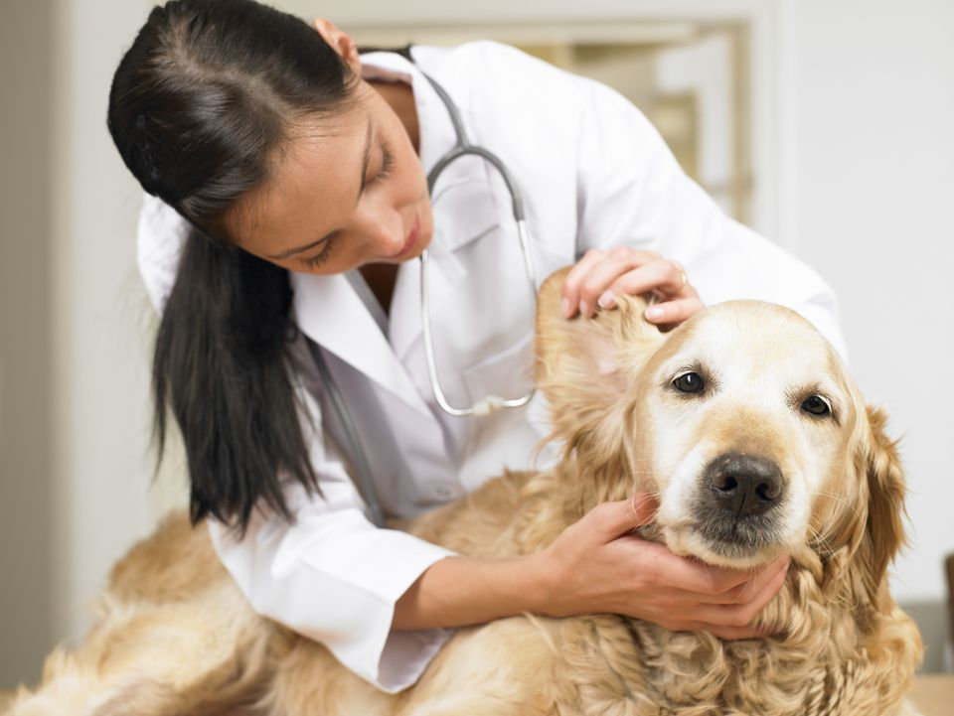

Table of Contents

Scope of Service 3

Introduction 3

Decision-Making Principles 3

The Clinic Setting 3

CDCH Clinic Service 4

CLINIC ELIGIBILITY 4

Eligibility area: 4

TIMES AND LOCATIONS OF CLINIC 5

Making an Appointment 5

Cancelling an Appointment 5

Medications, Vouchers & Advice 5

EMERGENCIES 5

WHAT TO BRING: 6

COSTS: 7

Consultation Costs 7

Preventative Care Treatment Costs 7

Medication Costs 7

Long term Medications 7

Prescriptions 7

Diagnostic Tests 7

SCHEDULE OF TREATMENTS 9

Veterinary Treatments Provided 9

Other services offered: 9

EMERGENCIES 9

Preventative Care 9

Diagnostic Tests 9

FULL TERMS & CONDITIONS OF CLINIC USAGE 10

Help Voucher Scheme 11

ELIGIBILITY 11

TO ISSUE A HELP VOUCHER WE NEED: 11

Proof of Benefits we accept 12

HELP VOUCHER SCHEME TERMS & CONDITIONS 12

Neutering Voucher Scheme 13

COSTS: 13

Dogs: 13

Cats: 13

Rabbits: 13

ELIGIBILITY 13

HOW TO GET A VOUCHER 13

Proof of Benefits we accept 13

NEUTERING VOUCHER SCHEME TERMS & CONDITIONS 14

# Scope of Service

### Introduction

CDCH is a charity that provides veterinary care to animal in our care and subsidised veterinary care to eligible clients through our clinics and voucher schemes as part of our charitable objectives.

We have a duty to ensure appropriate use of CDCH funds in order to maximise animal welfare and minimise suffering.

In this document, we seek to set out a scope of service that provides an overview of the care we offer.

### Decision-Making Principles

1. **Do No Harm**

No animal should be given ‘over’ treatment, which includes any treatment that would be worse for the animal than euthanasia or worse than a more conservative treatment in line with Veterinary Advice.

1. **Only provide tests/treatments that will improve/maintain patients’ Quality of Life (QOL)**

Consider the effect of any test/treatment on each patient’s overall QOL, considering all relevant aspects of their life, and potential responses to treatment options. Lengthening life is valuable for the animal only if it has a good QOL.

1. **Use resources in ways to achieve greatest welfare impact**

We have limited resources available, in particular time and money. Using resources on one patient effectively, albeit indirectly, deprives other animals. As such, we should aim for ‘welfare-efficient’ use of funds. We should consider whether costs are affordable not only for the owner, but also for us.

1. **Provide tests/treatments in ways that minimise any suffering**

Minimise any harms involved and mitigate them as much as possible in the circumstances, while achieving the desired (proportionate) aims.

### The Clinic Setting

The CDCH clinics offer preventative treatments and veterinary triage (which includes immediate care and/or referral) to our eligible clients. The CDCH clinic is **not** a low-cost veterinary care provider and does not offer the full range of veterinary care traditionally available at a veterinary practice. More detail on the treatments offered by the clinic may be found in our **‘Schedule of Treatments’**.

For these reasons, clients registering with the CDCH clinics will be strongly encouraged to register with a veterinary practice that does offer the full range of treatments.

# CDCH Clinic Service

## CLINIC ELIGIBILITY

Your animal should always be registered with a local Veterinary Practice, we are not a Veterinary Practice and cannot replace the services of one. Only three animals from the same household can be registered with our clinic at one time.

In order to qualify for help with veterinary care at the CDCH clinic you must fulfil the following criteria:

* 1. You must reside within our eligible catchment area as detailed below.
  2. Your animal should be neutered, or be neutered at the earliest opportunity *(we can help with the costs of neutering, please see our neutering voucher scheme)*.
  3. Your animal should be microchipped, or be microchipped at the earliest opportunity *(we offer free microchipping for any animal that is not microchipped as part of any appointment)*.
  4. You must be in receipt of a **means-tested benefit**:
     + Jobseeker’s allowance
     + Employment and support allowance (ESA)
     + Income support
     + Pension credit
     + Child tax credit
     + Working tax credit
     + Housing benefit
     + Council tax support
     + Universal credit

### 

|  |  |  |  |  |  |  |  |  |  |  |  |  |
| --- | --- | --- | --- | --- | --- | --- | --- | --- | --- | --- | --- | --- |
|  |  |  |  |  |  |  |  |  |  |  |  |  |

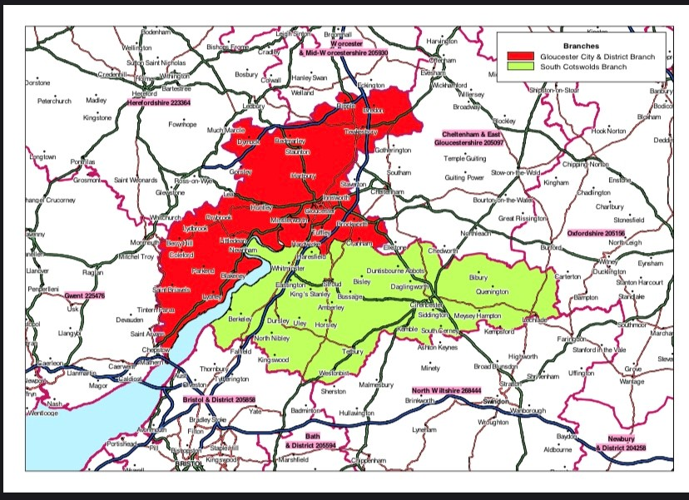

### Eligibility area:

If you are unsure if you are in our area please get in contact.

**If you are outside of our area but in receipt of eligible benefits, check with your local rspca to see if they offer a similar scheme. You can find your local branch on the rspca website** [**www.rspca.org.uk**](http://www.rspca.org.uk)

## TIMES AND LOCATIONS OF CLINIC

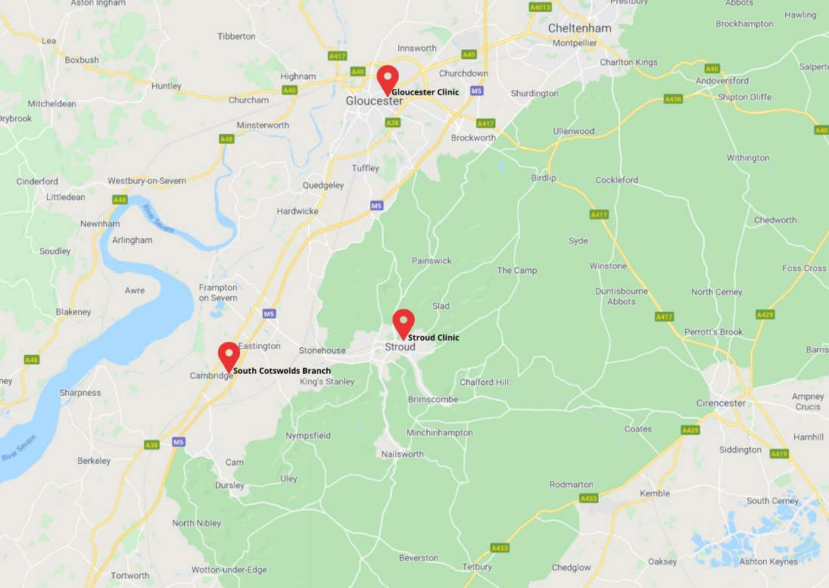

**FRIDAYS**

**10am – 12:20pm**

**Cotswolds Dogs and Cats Home - Beechmeadow Farm, Elmcote Lane, Cambridge, GL2 7AS**

### Making an Appointment

**Our clinic service is available by APPOINTMENT ONLY and strictly one animal per appointment.**

**Please arrive promptly, if you are late we may not be able to see you.**

To make an appointment please call our rehoming centre on **01453 890014.** Phone lines are open 10am to 4pm every day except Thursdays. Our phone lines are frequently busy, but we will answer as soon as we are able.

### Cancelling an Appointment

If you need to cancel your appointment, please call us **as soon as possible** as there may be another animal in need. There is an answer phone service if you are unable to speak with a team member or you can email reception@cdch.org.uk

If you have previously not shown for an appointment, for any future appointments payment for the consultation cost of £20 will be required at the time of booking. Failure to show for appointment will result in our services will be withdrawn.

### Medications

Medications must be paid for in advance and can only be collected during Clinic operating times or from the rehoming centre during opening hours.

EMERGENCIES

We are **not** a Veterinary Practice and cannot offer an emergency service. If your animal is seriously ill or has a major injury, you will need to take them to your registered vet.

***If you qualify you may be eligible for a Help Voucher towards the costs of veterinary treatment at a standard Veterinary Practice. Please see our section on Help Vouchers.***

## WHAT TO BRING:

To every appointment you **MUST** bring:

1. A form of payment we accept both cash and card at our Cambridge Clinic.
2. **Proof of benefits must be produced for EVERY attendance this must be:**

A recent letter or email dated within last 6 months

OR

An older letter or email AND a recent bank statement showing receipt of benefit

*(We can accept the benefit on a smartphone, but as signal can be difficult in the building we recommend bring something printed or getting a screenshot.)*

To your **FIRST** appointment you **MUST** bring:

1. The above documents
2. A photo ID
3. Proof of address (i.e. utility bill addressed to you)

## COSTS:

If you have queries surrounding costs please call us.

### Consultation Costs

**£20 per appointment per animal**

Only ONE of the following will be addressed during a 10-minute consultation

* Medical Consult
* Health Check for Flea / worming (includes 1 flea & worming treatment)
* Health Check for repeat medications / prescriptions

### Preventative Care Treatment Costs

We recommend having a robust preventative care regime to reduce the occurrence of secondary infections and medical ailments that can be associated with fleas and worms, i.e. Flea Allergy Dermatitis or Lungworm Infestation.

All flea and worming treatments given at the clinic are prescription only and requires a health check with our vet every 6 months. Following a health check (£20) you can receive flea and worming treatment for up to 6 months at the following prices.

* Flea treatments - £5 per pipette (monthly)
* Worming tablets - £3 per tablet

### Medication Costs

All medications will be charged as per our standard charging schedule and entirely depend on the type of medication needed.

### Long term Medications

As with flea and worming treatments, long term prescription medications given or prescribed at the clinic require a health check with our vet every 6 months. Following a health check (£20) you can receive medications without the need for an appointment for up to 6 months before needing another health check (dependent on the stability of the condition).

All medications will be charged as per our standard charging schedule and entirely depend on the type of medication needed.

**We need 7 days’ notice to dispense prescribed medications. Please call us in advance to arrange this. Dispensing of medication can only take place during clinic operating hours.**

### Prescriptions

Where possible we will issue a prescription for long term medications which can be fulfilled by yourself online. This requires an appointment as usual (£20) but the prescription letter itself is free. There are many low-cost online pharmacies that will be able to fill these for you.

### Diagnostic Tests available through Clinic

INTUN Intermediate screen with urine Dogs (Bloods) £64   
INTUN Intermediate screen with urine Cats (Bloods) £71  
Thyroid Monitoring Screen (T4MOP) £62  
Fine Needle Aspirate Cytology (CYTO1) (Lumps) £86  
SARCG Basic Faecal Screen Plus Giardia £79  
Basic Screen Urine (UCE-inclu culture and sens) £64  
Dipstick & specific gravity in house Included in the consultation fee  
Katkor for urine samples £2.85  
Glucometer (single test blood glucose) In house Included in the consultation fee  
Ear Cytology Included in the consultation fee

### Euthanasia & Cremation Service

Euthanasia is offered to registered clinic clients if it is in the best interests of the animal’s welfare and following a vet consultation. We do not offer a euthanasia service to unregistered clients, or first-time attendees unless we have a full medical history from their regular veterinary practice and our clinic vet, having assessed the animal and explored potential treatment plans, feels it is necessary for the animal’s welfare.

The options for cremation are listed below, please note that we are unable to offer payment plans for any of our services and payment will need to be made at the time of the treatment. If you prefer, you can make payment ahead of time.

Cremation   
There are two options available for cremation, individual, where the ashes are returned to the owner in a casket or scatter tube or a group cremation, where the ashes will be scattered in a pet cemetery.

Individual

This includes the cost of appointment and returning of ashes in a scatter tube or casket with a name engraved, please note that ashes will take up to 4 weeks to be returned, this is to keep the cost as low as possible:

Cat £110

Dog £120

### Group Cremation - No return of ashes

Cat £30

Dog £40

## SCHEDULE OF TREATMENTS

### Veterinary Treatments Provided

The CDCH Clinic is not a Veterinary Practice. You animal should always be registered at a regular Veterinary Practice. Our scope of service includes:

* Preventative Treatments (Flea and worming)
* Microchipping (included free with your consultation if your animal is not already chipped)
* Minor injury or illness
* Triage for non-emergency medical conditions
* Referrals (for conditions we are unable to assist with)
* Prescriptions for long-term medications
* Diagnostic tests as per our Diagnostic Schedule

### Other services offered:

* Neutering Vouchers
* Help Vouchers

If, following a consultation, your animal requires further treatment outside the scope of the CDCH Clinic we will provide a referral that you can take to another Veterinary Practice. We may be able to help with a Help Voucher.

EMERGENCIES

We are not a Veterinary Practice and cannot offer an emergency service. If your animal is seriously ill or has a major injury you will need to take them to your usual vet.

***If you qualify you may be eligible for a Help Voucher towards the costs of veterinary treatment at a standard Veterinary Practice. Please see our section on Help Vouchers.***

### Preventative Care

Flea and worming treatment is available at our clinic to those who are eligible. An animal must see our vet at least once every 6 months for a health check to receive any prescription medication.

We need 7 days’ notice to dispense prescribed medications which can be dispensed during clinic operating hours. This includes flea and worming treatments. Please call us in advance to arrange this.

### Diagnostic Tests

Diagnostic blood, urine, faecal and needle aspirate tests range from £50 to £80 and must be paid for at time of appointment. Blood tests may need another appointment to do the test.

## FULL TERMS & CONDITIONS OF CLINIC USAGE

* 1. Services as detailed above are strictly for eligible clients only as detailed in the eligibility criteria.
  2. Only 3 animals per household may be registered at one time for clinic services.
  3. We do not help animals that are insured, including payment of an excess.
  4. If you are unable to make the appointment time given you must inform us as soon as possible. Failure to do so will require payment up front for the consultation fee of £20 to be taken and it may result in a withdrawal of our services.
  5. Animals attending the clinic should be neutered or be neutered at the earliest opportunity unless there a vet has advised otherwise.
  6. All animals using the clinic should be microchipped to the owner at their current address, we offer free microchipping with our appointments.
  7. We require 7 days’ notice in order to dispense prescription only medication.
  8. We can only offer treatments that we can address during the consultation. If, following a consultation, your animal requires further treatment outside the scope of the CDCH Clinic we will provide a referral that you can take to another Veterinary Practice.
  9. The clinic can only address one medical condition at a time during the 10 minutes appointment, multiple concerns may require multiple appointments.
  10. We do not offer any clinic help towards the pregnancy or breeding animals.
  11. All bills must be settled at the time of appointment. We are unable to offer payment plans.
  12. We will dispense up to £5 worth of medication as part of your consultation, any additional costs for the medication will need to be paid for.
  13. Euthanasia is offered to **registered clinic clients** if it is in the best interests of the animal’s welfare. We **do not offer a euthanasia service to unregistered clients**, or first time attendees unless we have a full medical history from their regular veterinary practice **and** our clinic vet, having assessed the animal and explored potential treatment plans, feels it is necessary for the animals welfare.
  14. Abuse of staff will not be tolerated, we are all here to help and will do our best within our ability to do so.
  15. Anyone thought to be defrauding or abusing the clinic service will have services withdrawn permanently.
  16. Cotswolds Dogs and Cats Home reserves the right to refuse treatment.

# Help Voucher Scheme

A help voucher is designed to support your pets when they are most in need and you are facing an unexpected vet cost. These cannot be used for routine treatments, or towards vaccinations or other preventative care such as flea and worming treatments. They are intended for emergency or for unforeseen but necessary veterinary costs.

You can apply for a help voucher if the eligible vet bill is projected to be over £150. We will contribute 25% of the quoted cost up to a maximum of £100. For example, an eligible quote of £200 will attract a voucher contribution of £50. An eligible quote of £400 will attract the **maximum** voucher contribution of £100.

## ELIGIBILITY

In order to qualify for a help voucher you must fulfil the following criteria:

* 1. You must reside within our treatment area (call us if you are unsure).
  2. Your animal cannot be insured, we cannot help with insurance excess costs.
  3. You must be in receipt of a **means-tested benefit** such as:
     + Jobseeker’s Allowance or Employment and Support Allowance (ESA)
     + Tax Credits (Working or Child)
     + Income Support
     + Pension Credit
     + Housing Benefit
     + Council Tax Support
     + Universal Credit

Your animal does NOT need to be a clinic client, however, we would recommend that you register with the clinic for future needs and preventative care such as flea and worming treatments. You will also be eligible for a neutering voucher if you fulfil the above criteria.

We cannot issue a voucher retrospectively, i.e. if the bill has been paid, or for treatment previously given.

Payment is made directly to your Vet.

**You can only have one help voucher per household, within a 12 month period.**

Sadly our resources don’t allow us to help if you are not in receipt of a **means-tested benefit** – the best advice we can offer is to call round local vets and compare prices. A list of some of the local Veterinary Practices is included in this pack.

**If you are outside of our area but in receipt of eligible benefits, check with your local RSPCA to see if they offer a similar scheme. You can find your local branch on the RSPCA website** [**www.rspca.org.uk**](http://www.rspca.org.uk)

## TO ISSUE A HELP VOUCHER WE NEED:

* 1. A quote from your Veterinary Practice with the projected total cost of treatment.
  2. Your proof of benefits.
  3. Proof of address and ID.

In order to get your help voucher you need to contact us at CDCH as soon as possible to let us know what is happening.

We will then ask you to contact your vet to drop us an email with the estimate for the treatment needed.

You will also need to email through a copy of your ID, proof of benefits and proof of address (these need to be registered to the same address / person who is the owner of the animal). If you cannot email it to us please call us on **01453 890014** to arrange an alternative such as popping into the clinic or the rehoming centre during open hours.

### Proof of Benefits we accept

We accept the following proof of benefits

* 1. A recent letter or official email dated within the last 6 months
  2. An older letter or official email AND a recent bank statement showing receipt of benefit

We can accept proof of benefit from the DWP website on a smartphone, but as signal can be difficult in the building we recommend you bring something printed or get a screenshot showing your name, address and benefit type.

## HELP VOUCHER SCHEME TERMS & CONDITIONS

* 1. Help vouchers are strictly for eligible persons only as detailed in the eligibility criteria.
  2. A household may have **ONE** help voucher during a 12 month period.
  3. The help contribution is only for a quote totalling an eligible projected cost of over £150. The voucher will cover 25% of the total bill up to a maximum contribution of £100. I.e. An eligible quote of £200 will attract a voucher contribution of £50. An eligible quote of £400 will attract the **maximum** voucher contribution of £100.
  4. We do not help animals that are insured, including payment of an excess.
  5. Help vouchers cannot be used towards pregnancy/breeding related treatments.
  6. We cannot offer help or credit plans towards any remaining vets bills, these are the responsibility of the owner and any payment plans must be agreed with the Veterinary Practice.
  7. A help voucher is not paid retrospectively on treatment already given on settled accounts.
  8. A help voucher cannot be used to settle a debt with the vets, or to credit an owner’s account with their veterinary practice.
  9. CDCH reserve the right to adjust a help contribution based on removing ineligible items from a final bill. If treatment is not ‘in the spirit’ of the help vouchers intended purpose our payment may be adjusted, i.e. a voucher was issued for treatment of a broken leg, but whilst under anaesthesia a dental was also requested by the owner. The owner assumes responsibility for clearing any remaining debt with the veterinary practice.
  10. Abuse of staff will not be tolerated, we are all here to help and will do our best within our ability to do so.
  11. Anyone thought to be defrauding or abusing the help voucher scheme will have services withdrawn permanently.
  12. Cotswolds Dogs and Cats Home reserves the right to refuse to issue a help voucher, or to refuse payment if abuse of the scheme is suspected.

# Neutering Voucher Scheme

**A neutering voucher is designed to help you cover the cost of getting your animal neutered.**

**We offer neutering vouchers for cats, dogs and rabbits.**

The voucher offers a fixed contribution towards the cost of a spay or castrate procedure, pain meds and a buster collar to go home with. It can also be used towards the cost of a microchip during the spay/castrate procedure if your animal is not already microchipped.

CDCH will issue you with a voucher to give to your vet. The vet will then be able to invoice CDCH for the amount shown on the voucher in relation to your animal’s spay or castrate procedure. You will be responsible for the remainder of the bill.

Your voucher will have an expiry date of 3 months, after this date the voucher cannot be used.

## Voucher Value/CDCH Contribution:

|  |  |  |
| --- | --- | --- |
| Dogs: Female £90  Male £67 | Cats: Female £33  Male £22 | Rabbits: Female £48  Male £41 |

## ELIGIBILITY

In order to qualify for a neutering voucher you must fulfil the following criteria:

* 1. You must reside within our treatment area (please see our map, call us if you are unsure).
  2. You must be in receipt of a **means-tested benefit**:
* Jobseeker’s Allowance
* Employment and Support Allowance (ESA)
* Child Tax Credit
* Working Tax Credit
* Pension Credit
* Housing Benefit
* Council Tax Support
* Universal Credit

Your animal does NOT need to be a clinic client, however, we would recommend that you register with the clinic for future needs and preventative care.

We cannot issue a neutering voucher retrospectively, please contact us to request a voucher prior to any treatment.

**If you are outside of our area but in receipt of eligible benefits, check with your local RSPCA to see if they offer a similar scheme. You can find your local branch on the RSPCA website** [**www.rspca.org.uk**](http://www.rspca.org.uk/)

## HOW TO GET A VOUCHER

Please email [reception@cdch.org.uk](mailto:reception@cdch.org.uk) with your request or you can call 01453 890014.

### Proof of Benefits we accept

We accept either of the following:

* 1. A recent letter or official email dated within the last 6 months
  2. An older letter or official email AND a recent bank statement showing receipt of benefit

We can accept proof of benefit from the DWP website on a smartphone, but as signal can be difficult in the building we recommend you bring something printed or get a screenshot showing your name, address and benefit type.

## NEUTERING VOUCHER SCHEME TERMS & CONDITIONS

* 1. Neutering vouchers are strictly for eligible persons only as detailed in the eligibility criteria.
  2. There is no strict limit on the number of animals you can get a neutering voucher for, but CDCH do reserve the right to refuse to issue one if abuse of the scheme is suspected.
  3. Neutering Vouchers expire 3 months after the date of issue and cannot be used after this point.
  4. Neutering vouchers are subject to availability. CDCH will issue a fixed number of vouchers each year on a first come, first served basis.
  5. All animals will be microchipped to the owner during the neutering, unless there is a medical reason why they are unable to be.
  6. The voucher is a contribution towards a spay or castrate procedure, pain meds and a buster collar to go home with.
  7. All costs above the value of the voucher are the responsibility of the owner.
  8. The owner assumes responsibility for clearing any remaining debt with the veterinary practice.
  9. We cannot offer help or credit plans towards any remaining vets bills, these are the responsibility of the owner and any payment plans must be agreed with the Veterinary Practice.
  10. A neutering voucher cannot be used retrospectively on treatment already given or on settled accounts.
  11. A neutering voucher cannot be used to settle a debt with the vets, or to credit an owner’s account with their veterinary practice.
  12. Vouchers must be used for the animal they have been issued to and cannot be given or sold to another party.
  13. CDCH reserve the right to refuse payment if the animal, owner or owners address is different on the veterinary account to the details given when the neutering voucher was given.
  14. Abuse of staff will not be tolerated, we are all here to help and will do our best within our ability to do so.
  15. Anyone thought to be defrauding or abusing the clinic service or the neutering vouchers will have services withdrawn permanently and will not be eligible for future help or clinic services.
  16. Cotswolds Dogs and Cats Home reserves the right to refuse to issue a neutering voucher, or to refuse payment if abuse of the scheme is suspected.