2024

Cotswolds Dogs and Cats Home
December 2018 (Updated February 2024)
Clinic Registration & Information Pack
Table of Contents
Scope of Service 3
Introduction 3
Decision-Making Principles 3
The Clinic Setting 3
CDCH Clinic Service 4
CLINIC ELIGIBILITY 4
Eligibility area: 5
TIMES AND LOCATIONS OF CLINIC 6
Making an Appointment 6
Cancelling an Appointment 6
Medications and Vouchers 6
EMERGENCIES 7
WHAT TO BRING: 8
COSTS: 9
Consultation Costs 9
Preventative Care Treatment Costs 9
Medication Costs 9
Long term Medications 9
Prescriptions 9
Diagnostic Tests available through Clinic 9
SCHEDULE OF TREATMENTS 10
Veterinary Treatments Provided 10
Additional services offered: 10
EMERGENCIES 10
Preventative Care 10
Diagnostic Tests 10
FULL TERMS & CONDITIONS OF CLINIC USAGE 11
Help Voucher Scheme 12
ELIGIBILITY 12
TO ISSUE A HELP VOUCHER WE NEED: 12
Proof of Benefits we accept 13
HELP VOUCHER SCHEME TERMS & CONDITIONS 13
Neutering Voucher Scheme 14
Voucher Value/CDCH Contribution: 14
Dogs: 14
Cats: 14
Rabbits: 14
ELIGIBILITY 14
HOW TO GET A VOUCHER 15
Proof of Benefits we accept 15
NEUTERING VOUCHER SCHEME TERMS & CONDITIONS 16

Scope of Service

Introduction
The Cotswolds Dogs and Cats Home is an independent charity that provides veterinary care to the animals in our care, as well as subsidised veterinary care to eligible clients through our clinics and voucher schemes.
We have a duty to ensure the appropriate use of CDCH funds, in order to maximise animal welfare and minimise suffering.
In this document, we set out a scope of service that provides an overview of the care we offer.

Decision-Making Principles
- Do No Harm
No animal should be given ‘over’ treatment, which includes any treatment that would be worse for the animal than euthanasia, or worse than a more conservative treatment in line with Veterinary Advice.
- Only provide testing/treatments that will improve/maintain a patients’ Quality of Life (QOL)
Consider the effect of any testing/treatment on each patient’s overall QOL, considering all relevant aspects of their life, and potential responses to treatment options. Lengthening life is valuable for the animal only if good QOL can also be guaranteed.
- Use resources in ways to achieve greatest welfare impact
CDCH have limited resources available, in particular time and money. Using resources on one patient effectively, albeit indirectly, deprives other animals. As such, we should aim for ‘welfare-efficient’ use of funds. CDCH must consider whether costs are affordable not only for the owner, but also for the charity.
- Provide tests/treatments in ways that minimise any suffering
Minimise any harms involved and mitigate them as much as possible in the circumstances, while achieving the desired (proportionate) aims.

The Clinic Setting
The CDCH clinics offer preventative treatments and veterinary triage (which includes immediate care and/or referral) to our eligible clients. The CDCH clinic is not a low-cost veterinary care provider and does not offer the full range of veterinary care traditionally available at a veterinary practice. More detail on the treatments offered by the clinic may be found in our ‘Schedule of Treatments’.
For these reasons, clients registering with the CDCH clinics will be strongly encouraged to register with a veterinary practice that does offer the full range of treatments.
Please note, that in order to comply with RCVS standards, we must declare any treatment given to your animals with your registered veterinary practice and ensure that you have access to a 24-hour veterinary provision after treatment has been administered by out Vet.
CDCH do not provide an out-of-hours/emergency service, so if your animal is not registered with a veterinary practice, you will be referred to Vale Vets in Dursley for any out-of-hours/emergency treatment you should require as a result of the treatment given by our Vet.
Please call Vale Vets on: 01453 542 092 for their emergency/out-of-hours service. Please note that the emergency/out-of-hours service is chargeable at the rate set by Vale Vets and all fees must be paid at the time of your appointment.

CDCH Clinic Service

CLINIC ELIGIBILITY
Your animal should always be registered with a local Veterinary Practice, CDCH are not a Veterinary Practice and cannot replace the services of one. Only three animals from the same household can be registered with the CDCH clinic at one time.
In order to qualify for help with veterinary care at the CDCH clinic you must fulfil the following criteria:
  - You must reside within our eligible catchment area as detailed below.
  - Your animal should be neutered, or be neutered at the earliest opportunity (we can help with the costs of neutering, please see our neutering voucher scheme).
  - Your animal should be microchipped, or be microchipped at the earliest opportunity (we offer free microchipping for any animal that is not microchipped as part of any appointment).
  - You must be in receipt of one of the following means-tested benefits:

    - Jobseeker’s allowance
    - Employment and support allowance (ESA)
    - Income support
    - Pension credit
    - Child tax credit
    - Working tax credit
    - Housing benefit
    - Council tax support
    - Universal credit

Sadly, our resources don’t allow us to help if you are not in receipt of a means-tested benefit – the best advice CDCH can offer is to call round local vets and compare prices. A list of some of the local Veterinary Practices is included in this pack.

Eligibility area:
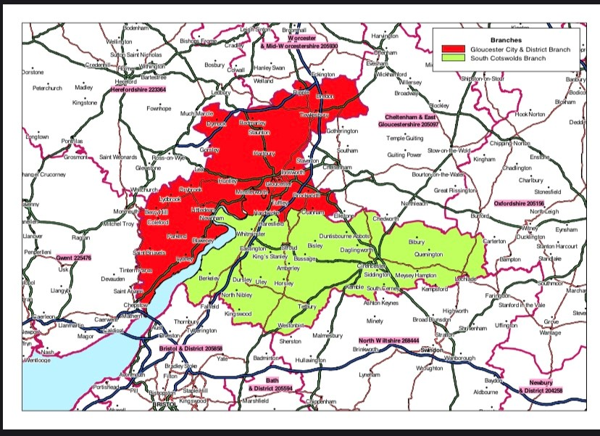
If you are unsure if you are in our area please get in contact.

If you are outside of our area but in receipt of eligible benefits, check with your local RSPCA to see if they offer a similar scheme. You can find your local branch on the RSPCA website www.rspca.org.uk.

TIMES AND LOCATIONS OF CLINIC

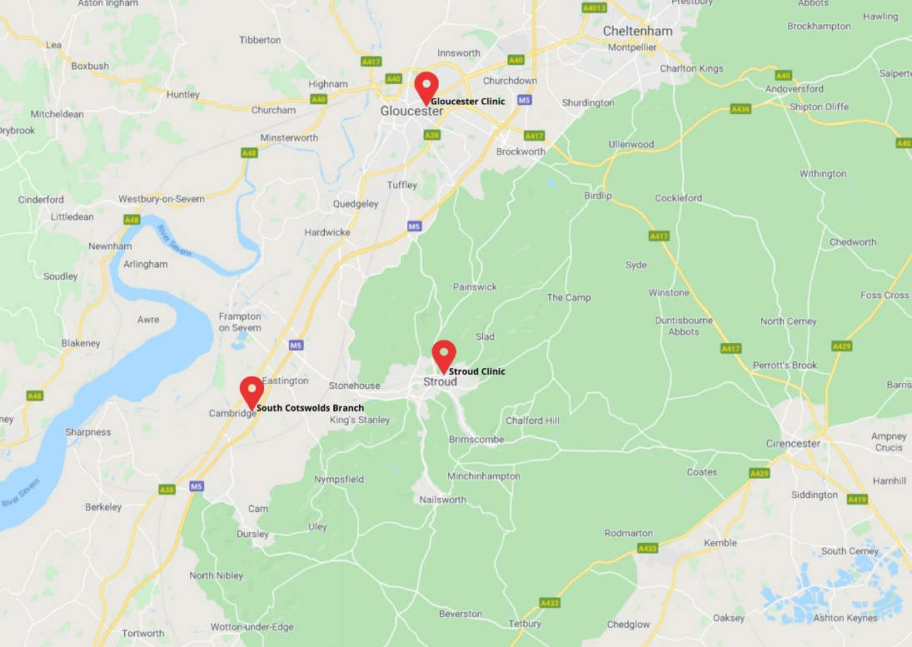

TUESDAYS
10am to 12.20pm
Cotswolds Dogs and Cats Home - Beechmeadow Farm, Elmcote Lane, Cambridge, GL2 7AS

Making an Appointment
Our clinic service is available by APPOINTMENT ONLY and strictly one animal per appointment.
Please arrive promptly, if you are late we may not be able to see you.
To make an appointment please contact our rehoming centre on 01453 890014 or reception@cdch.org.uk. Phone lines are open 10am to 4pm every day, but are closed on Thursdays. Our phone lines are frequently busy, but we will answer as soon as we are able.

Cancelling an Appointment
If you need to cancel your appointment, please call us as soon as possible as there may be another animal in need. There is an answer phone service if you are unable to speak with a team member or you can email reception@cdch.org.uk.
Our services will be withdrawn for repeated no shows.

Medications and Vouchers
Medications and vouchers must be paid for in advance and can only be collected from the rehoming centre during opening hours. You will be contacted when your requested medications are ready to be collected.
Dispensing Fees
All repeat prescriptions (where no consult has been made) will be charged a dispensing fee of £4.50.
EMERGENCIES
We are NOT a Veterinary Practice and cannot offer an emergency service. If your animal is seriously ill or has a major injury, you will need to take them to your registered vet or an emergency practice.
If you qualify you may be eligible for a Help Voucher towards the costs of veterinary treatment at a standard Veterinary Practice. Please see our section on Help Vouchers.

WHAT TO BRING:

To every appointment you MUST bring:
- A form of payment we accept both cash and card at our Cambridge Clinic
- Proof of benefits must be produced for your first attendance this must be:
A recent letter or email dated within last 6 months
OR
An older letter or email AND a recent bank statement showing receipt of benefit

(We can accept the benefit on a smartphone, but as signal can be difficult in the building we recommend bring something printed or getting a screenshot.)

To your FIRST appointment you MUST bring:
- Proof of benefits, this must be:
- A recent letter or email dated within last 6 months
OR
- An older letter or email AND a recent bank statement showing receipt of benefit

(We can accept the benefit on a smartphone, but as signal can be difficult in the building we recommend bring something printed or getting a screenshot.)
- A photo ID

COSTS:
If you have queries surrounding costs please call us.

Consultation Costs
£20 per appointment per animal

Preventative Care Treatment Costs
We recommend having a robust preventative care regime to reduce the occurrence of secondary infections and medical ailments that can be associated with fleas and worms, i.e. Flea Allergy Dermatitis or Lungworm Infestation.
All flea and worming treatments given at the clinic are prescription only and requires a health check with our vet every 6 months. Following a health check (£20) you can receive flea and worming treatment for up to 6 months at the following prices.
- Flea treatments - £5 per pipette (monthly)
- Worming tablets - £3 per tablet

Medication Costs
All medications will be charged as per our standard charging schedule and entirely depend on the type of medication needed. We do not charge a prescription fee for our medications, meaning they are more affordable than private practice.

Long term Medications
As with flea and worming treatments, long term prescription medications given or prescribed at the clinic require a health check with our vet every 6 months. Following a health check (£20) you can receive medications without the need for an appointment for up to 6 months before needing another health check (dependent on the stability of the condition).
All medications will be charged as per our standard charging schedule and entirely depend on the type of medication needed.
We need 7 days’ notice to dispense prescribed medications. Please call us in advance to arrange this. Dispensing of medication can only take place during clinic operating hours.

Prescriptions
Where possible we will issue a prescription for long term medications which can be fulfilled by yourself online. This requires an appointment as usual (£20) but the prescription letter itself is free. There are many low-cost online pharmacies that will be able to fill these for you.

Diagnostic Tests available through Clinic
WELN (Wellness Profile, Non-interpreted) - £66.45
WELI (Wellness Profile, Interpreted) - £72.79
Total T4 only - £52.34
T4 Montoring (T4MOP) - £67.51
Fine Needle Aspirate Cytology - £72.22
Full Urinalysis (Inc culture) - £75.87
Faecal Analysis - £61.49
*Prices include sampling fee and interpretation*

SCHEDULE OF TREATMENTS

Veterinary Treatments Provided
The CDCH Clinic is not a Veterinary Practice. You animal should always be registered at a regular Veterinary Practice. Our scope of service includes:
- Preventative Treatments (Flea and worming)
- Microchipping (included free with your consultation if your animal is not already chipped)
- Minor injury or illness
- Triage for non-emergency medical conditions
- Referrals (for conditions we are unable to assist with)
- Prescriptions for long-term medications
- Diagnostic tests as per our Diagnostic Schedule

Additional services offered:
- Neutering Vouchers
- Help Vouchers
If, following a consultation, your animal requires further treatment outside the scope of the CDCH Clinic we will provide a referral that you can take to another Veterinary Practice. We may be able to help with a Help Voucher.
EMERGENCIES
We are not a Veterinary Practice and cannot offer an emergency service. If your animal is seriously ill or has a major injury you will need to take them to your usual vet.
If you qualify you may be eligible for a Help Voucher towards the costs of veterinary treatment at a standard Veterinary Practice. Please see our section on Help Vouchers.

Preventative Care
Flea and worming treatments are available at our clinic to those who are eligible. An animal must see our vet at least once every 6 months for a health check to receive any prescription medication.
We need 7 days’ notice to dispense prescribed medications which can be dispensed during clinic operating hours. This includes flea and worming treatments. Please call us in advance to arrange this.

Diagnostic Tests
Diagnostic blood, urine, faecal and needle aspirate tests range from £50 to £80 and must be paid for at the time of appointment. Blood tests may need 2nd appointment to do the test.

FULL TERMS & CONDITIONS OF CLINIC USAGE
  - Services as detailed above are strictly for eligible clients only as detailed in the eligibility criteria.
  - Only 3 animals per household may be registered at one time for clinic services.
  - If you are unable to make the appointment time given you must inform us as soon as possible. Failure to do so may result in a withdrawal of our services.
  - Animals attending the clinic should be neutered or be neutered at the earliest opportunity unless a vet has advised otherwise.
  - All animals using the clinic should be microchipped to the owner at their current address, we offer free microchipping with our appointments.
  - We require 7 days’ notice in order to dispense prescription only medication.
  - We can only offer treatments that we can address during the consultation. If, following a consultation, your animal requires further treatment outside the scope of the CDCH Clinic we will provide a referral that you can take to another Veterinary Practice.
  - The clinic can only address one medical condition at a time during the 10 minutes appointment, multiple concerns may require multiple appointments.
  - We do not offer any clinic help towards the pregnancy or breeding animals.
  - All bills must be settled at the time of appointment. We are unable to offer payment plans.
  - Euthanasia is offered to registered clinic clients if it is in the best interests of the animal’s welfare. We do not offer a euthanasia service to unregistered clients, or first time attenders unless we have a full medical history from their regular veterinary practice and our clinic vet, having assessed the animal and explored potential treatment plans, feels it is necessary for the animals welfare.
  - Cremation services are offered at an additional cost. We must receive full payment for any cremation services on the day of euthanasia.
  - Abuse of staff will not be tolerated, we are all here to help and will do our best within our ability to do so.
  - Anyone thought to be defrauding or abusing the clinic service will have services withdrawn permanently.
  - The Cotswolds Dogs and Cats Home reserves the right to refuse treatment.

Help Voucher Scheme
A help voucher is designed to support your pets when they are most in need and you are facing an unexpected vet cost. These cannot be used for routine treatments, or towards vaccinations or other preventative care such as flea and worming treatments. They are intended for emergency or for unforeseen but necessary veterinary costs.
You can apply for a help voucher if the eligible vet bill is projected to be over £150. We will contribute 25% of the quoted cost up to a maximum of £150. For example, an eligible quote of £200 will attract a voucher contribution of £50. An eligible quote of £400 will attract the maximum voucher contribution of £150.

ELIGIBILITY
In order to qualify for a help voucher you must fulfil the following criteria:
  - You must reside within our treatment area (call us if you are unsure).
  - Your animal cannot be insured, we cannot help with insurance excess costs.
  - You must be in receipt of a means-tested benefit such as:
    - Jobseeker’s Allowance or Employment and Support Allowance (ESA)
    - Tax Credits (Working or Child)
    - Income Support
    - Pension Credit
    - Housing Benefit
    - Council Tax Support
    - Universal Credit

Your animal does not need to be a clinic client to qualify for a help voucher. However, we would recommend that you register with the clinic for future needs and preventative care such as flea and worming treatments. You will also be eligible for a neutering voucher if you fulfil the above criteria.

We cannot issue a voucher retrospectively, for example, if the bill has been paid or for treatment previously given.

Payment is made directly to your Vet.

You can only have one help voucher per household, within a 12-month period.

Sadly, our resources don’t allow us to help if you are not in receipt of a means-tested benefit – the best advice we can offer is to call round local vets and compare prices. A list of some of the local Veterinary Practices is included in this pack.

If you are outside of our area but in receipt of eligible benefits, check with your local RSPCA to see if they offer a similar scheme. You can find your local branch on the RSPCA website www.rspca.org.uk.

TO ISSUE A HELP VOUCHER WE NEED:
  - A quote from your Veterinary Practice with the projected total cost of treatment.
  - Your proof of benefits.
  - Proof of address and ID.
In order to get your help voucher, you need to contact us at CDCH as soon as possible.
We will then ask you to contact your vet to drop us an email with the estimate for the treatment needed.
You will also need to email through a copy of your ID, proof of benefits and proof of address (these need to be registered to the same address / person who is the owner of the animal). If you cannot email this to us please call us on 01453 890014 to arrange an alternative, such as popping into the clinic or the rehoming centre during open hours.

Proof of Benefits we accept
We accept the following proof of benefits
  - A recent letter or official email dated within the last 6 months
  - An older letter or official email AND a recent bank statement showing receipt of benefit

We can accept proof of benefit from the DWP website on a smartphone, but as signal can be difficult in the building we recommend you bring something printed or get a screenshot showing your name, address and benefit type.

HELP VOUCHER SCHEME TERMS & CONDITIONS
  - Help vouchers are strictly for eligible persons only as detailed in the eligibility criteria.
  - A household may have ONE help voucher during a 12-month period.
  - The help contribution is only for a quote totalling an eligible projected cost of over £150. The voucher will cover 25% of the total bill up to a maximum contribution of £150. For example, an eligible quote of £200 will attract a voucher contribution of £50. An eligible quote of £400 will attract the maximum voucher contribution of £150.
  - Help vouchers cannot be used towards pregnancy/breeding related treatments.
  - We cannot offer help or credit plans towards any remaining vets bills, these are the responsibility of the owner and any payment plans must be agreed with the Veterinary Practice.
  - A help voucher is not paid retrospectively on treatment already given on settled accounts.
  - A help voucher cannot be used to settle a debt with the vets, or to credit an owner’s account with their veterinary practice.
  - CDCH reserve the right to adjust a help contribution based on removing ineligible items from a final bill. If treatment is not ‘in the spirit’ of the help vouchers intended purpose our payment may be adjusted, for example, a voucher was issued for treatment of a broken leg, but whilst under anaesthesia a dental was also requested by the owner. The owner assumes responsibility for clearing any remaining debt with the veterinary practice.
  - Abuse of staff will not be tolerated, we are all here to help and will do our best within our ability to do so.
  - Anyone thought to be defrauding or abusing the help voucher scheme will have services withdrawn permanently.
  - The Cotswolds Dogs and Cats Home reserves the right to refuse to issue a help voucher, or to refuse payment if abuse of the scheme is suspected.

Neutering Voucher Scheme
A neutering voucher is designed to help you cover the cost of getting your animal neutered.
We offer neutering vouchers for cats, dogs and rabbits.
The voucher offers a fixed contribution towards the cost of a spay or castrate procedure, pain meds and a buster collar to go home with. It can also be used towards the cost of a microchip during the spay/castrate procedure if your animal is not already microchipped.
CDCH will issue you with a voucher to give to your vet. The vet will then be able to invoice CDCH for the amount shown on the voucher in relation to your animal’s spay or castrate procedure. You will be responsible for the remainder of the bill.
Your voucher will have an expiry date of 3 months, after this date the voucher cannot be used.

Voucher Value/CDCH Contribution:
Dogs:  Female £120  Male £85 | Cats:  Female £37  Male £25 | Rabbits:  Female £48  Male £41

ELIGIBILITY
In order to qualify for a neutering voucher you must fulfil the following criteria:
  - You must reside within our treatment area (please see our map, call us if you are unsure).
  - You must be in receipt of a means-tested benefit:
    - Jobseeker’s Allowance
    - Employment and Support Allowance (ESA)
    - Child Tax Credit
    - Working Tax Credit

Income Support
    - Pension Credit
    - Housing Benefit
    - Council Tax Support
    - Universal Credit

Your animal does not need to be a clinic client to be eligible for a neuter voucher. However, we would recommend that you register with the clinic for future needs and preventative care.
We cannot issue a neutering voucher retrospectively.
If you are outside of our area but in receipt of eligible benefits, check with your local RSPCA to see if they offer a similar scheme. You can find your local branch on the RSPCA website www.rspca.org.uk

HOW TO GET A VOUCHER
To get a voucher you need to bring your proof of benefits, ID and proof of address to a Clinic during clinic opening hours or to our Rehoming Centre during opening hours. (12-4 every day except Thursdays).

Proof of Benefits we accept
We accept either of the following:
  - A recent letter or official email dated within the last 6 months
  - An older letter or official email AND a recent bank statement showing receipt of benefit
We can accept proof of benefit from the DWP website on a smartphone, but as signal can be difficult in the building we recommend you bring something printed or get a screenshot showing your name, address and benefit type.

NEUTERING VOUCHER SCHEME TERMS & CONDITIONS
  - Neutering vouchers are strictly for eligible persons only as detailed in the eligibility criteria.
  - There is no strict limit on the number of animals you can get a neutering voucher for, but CDCH do reserve the right to refuse to issue one if abuse of the scheme is suspected.
  - Neutering Vouchers expire 3 months after the date of issue and cannot be used after this point.
  - Neutering vouchers are subject to availability. CDCH will issue a fixed number of vouchers each year on a first come, first served basis.
  - The voucher is a contribution towards a spay or castrate procedure, pain meds and a buster collar to go home with.
  - All costs above the value of the voucher are the responsibility of the owner.
  - The owner assumes responsibility for clearing any remaining debt with the veterinary practice.
  - We cannot offer help or credit plans towards any remaining vets bills, these are the responsibility of the owner and any payment plans must be agreed with the Veterinary Practice.
  - A neutering voucher cannot be used retrospectively on treatment already given or on settled accounts.
  - A neutering voucher cannot be used to settle a debt with the vets, or to credit an owner’s account with their veterinary practice.
  - Vouchers must be used for the animal they have been issued to and cannot be given or sold to another party.
  - CDCH reserve the right to refuse payment if the animal, owner or owners address is different on the veterinary account to the details given when the neutering voucher was given.
  - Abuse of staff will not be tolerated, we are all here to help and will do our best within our ability to do so.
  - Anyone thought to be defrauding or abusing the clinic service or the neutering vouchers will have services withdrawn permanently and will not be eligible for future help or clinic services.
  - The Cotswolds Dogs and Cats Home reserves the right to refuse to issue a neutering voucher, or to refuse payment if abuse of the scheme is suspected.

